
Basildon & Brentwood
February 2025
Carers & Helpers Noticeboard
A central point of contact for support for unpaid carers 0300 303 9988 Phonelines are open Monday to Friday 8am-7pm Saturday 9am-12pm E: provide.essexwellbeing@nhs.net or https://essexwellbeingservice.co.uk/support/carers/

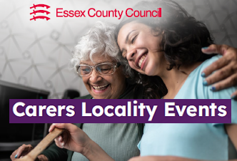

are being held across regions of Essex next month. Each event will be split into 2 sessions with the first 1½hr devoted solely to professionals who work in health or social care, education, the voluntary or community sector, who in their working role may sometimes have contact with unpaid/ family carers.
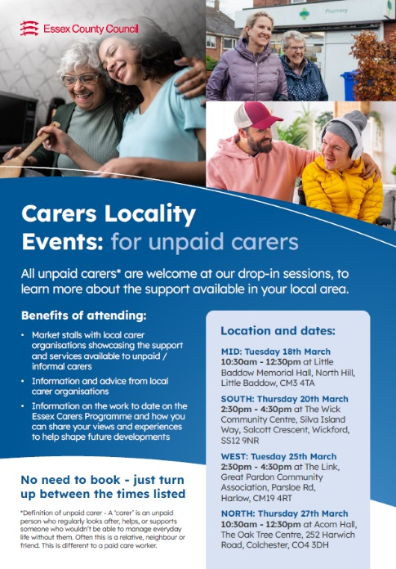
There will be opportunity to informally network with other professionals across the system and to learn about the range of support services locally available to unpaid carers. As well as finding out about the work done to date on the Essex Carers Programme and the next steps planned by the Council. Use the QR to . book a place on one of the professional sessions or E: essex.carers@essex.gov.uk
Region | MID Tuesday 18th March | SOUTH Thursday 20th March | WEST Tuesday 25th March | NORTH Thursday 27th March
Venue | Little Baddow Memorial Hall North Hill CM3 4TA | The Wick Community Centre, Wickford SS12 9NR | The Link, Great Pardon Community Ass. CM19 4RT | Acorn Hall, The Oak Tree Centre, Colchester CO4 3DH
Professionals only  (booking required) | 9:00am - 10:30am | 1:00pm - 2:30pm | 1:00pm - 2:30pm | 9:00am - 10:30am
Professionals & general public (no booking required) | 10:30am - 12:30pm | 2:30pm - 4:30pm | 2:30pm - 4:30pm | 10:30am - 12:30pm

is the new name of the Rural Community Council of Essex’s community led social project, United in Kind. RCCE is part of EWS. The work of Kinder Essex coaches is to reduce social isolation and to support people’s wider health and wellbeing by connecting people to local groups/activities, through volunteering or by of acts of kindness.
The second part of the day is open to all unpaid carers/ family/ friends who regularly look after or support someone who could not manage without their help. No prior booking is needed to attend as these sessions will take the form of an open, drop in market stall event with lots of local support services in attendance.
Email Rachel.Amoss2@essex.gov.uk if your GP Practice or health clinic would like printed leaflets (as shown on the left) or A4 posters to advertise these events to patients/ service users.

Coaches also work with local groups and organisations in helping to start new community projects and with extending existing services. In 2024, the project recruited 500 new volunteers and assisted over 250 groups and organizations. And, in the last five years has helped 20,000 people to become more connected, supported 1,500 new community initiatives and encouraged 46,000 acts of kindness. Click logo for more info about the service.

The Sleep Well and Hug in A Shrug projects are examples of these acts of kindness where local volunteers make eye masks for hospital patients or knitted/crocheted items to give comfort to others in need. Volunteers can make items at home or at one of Kinder Essex’s sociable group sessions. To find out more about the service click logo or call EWS on 0300 303 9988

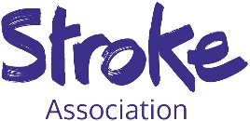
The Stroke Association offers a wide range of information on preventing, understanding, and life after a stroke, for professionals, stroke survivors and their Carers. These guides are free to download and are available in a variety of languages, in large print and as audio recordings. For stroke survivors with
communication difficulties it also has a range of free tools that can help the person communicate both at
home and in healthcare settings. Click logo above for this information or call the Stroke Support Helpline on 0303 3033 100.

In South West Essex, the Association offers a personalised stroke recovery service for adult stroke survivors and their family carers (including those who have experienced a TIA/mini stroke). Through phone calls and/or home visits, a SA coordinator can provide practical advice, tailored information and emotional support to both survivors and carers to help with managing daily activities, and with rebuilding confidence and independence after a stroke. For more info E: michelle.turner@stroke.org.uk or call 07940 107844
are hosting a free CVD Health Event at Shotgate Community Hall on Saturday 8th March between 10am-2pm. The event is offering pre-bookable NHS Health Checks, Atrial Fibrillation checks and weight checks to eligible patients registered to either Robert Frew, Swanwood or London Road surgeries. Plus, anyone can drop in on the day to have a nurse check their blood pressure and to speak to any of the health and wellbeing services in attendance. Between 12-12:30pm there will be a talk on lifestyle and heart health given by Dr Henry Savage, consultant cardiologist and heart failure lead of the Essex Cardiothoracic Centre at Basildon & Thurrock University Hospital.

are hosting a free CVD Health Event at Shotgate Community Hall on Saturday 8th March between 10am-2pm. The event is offering pre-bookable NHS Health Checks, Atrial Fibrillation checks and weight checks to eligible patients registered to either Robert Frew, Swanwood or London Road surgeries. Plus, anyone can drop in on the day to have a nurse check their blood pressure and to speak to any of the health and wellbeing services in attendance. Between 12-12:30pm there will be a talk on lifestyle and heart health given by Dr Henry Savage, consultant cardiologist and heart failure lead of the Essex Cardiothoracic Centre at Basildon & Thurrock University Hospital.


.


is an online resource offering expert information on palliative care and end of life care for people living with a life-limiting illness, their family and loved ones. Life-limiting illnesses such as chronic lung, heart, kidney or neurological diseases, dementia or general frailty, as well as incurable cancer, are often long-term and progressive and so a person’s care needs can change over time. The term ‘end of life care’ refers specifically to the care provided during the last year of a person’s life.

The HPAL website aims to support anyone who needs, or is involved with, palliative and end of life care, whether in a hospice, care home or in their own home. Articles on the website cover a broad range of topics to help with a person’s physical, emotional, social, financial, legal and spiritual needs with many written specifically with informal carers in mind. Topics covered include:
- Managing physical symptoms and pain
- Practical guides for caring for someone at home
- Guidance for people facing bereavement and grief
- How to prepare children that a parent or grandparent is dying
- Guidance on advance care planning and thinking about care needs and wishes for the future.
Click on logo for the sites home page or go to https://mse.medindex.co.uk/p


provides information and support to anyone recently diagnosed, or who is living, with a life-limiting illness and lives in Basildon or Thurrock. It offers a number of therapeutic interventions that can support a person’s social, psychological and emotional wellbeing, including a wig bank service for those who have lost their hair due to treatment/ alopecia. St Luke’s specialist physiotherapists/ occupational therapists can help people to maintain independence and mobility at home, as well as giving guidance to family/ loved ones on how to safely move and handle someone whilst caring.
For families and loved ones the Carers Support Team offer a range of practical and financial advice, training and emotional support. This support is provided via peer-to-peer support groups held onsite at the Hospice or at community drop-in sessions across south west Essex, or 1-to-1 over phone, email or video link (ZOOM). Plus, will link carers to other resources or support networks & groups.
The specialist Hospice Community team can support caring for someone at home or in a residential care setting by:
- OneResponse, a 24hr 7days-a-week telephone help line offering expert advice and guidance - 01268 526 259
- liaising with other health/social care professionals to help organise respite or nighttime support, or to prevent unwanted hospital admission
- assisting hospital discharge & referral into community care for those whose condition is complex or is rapidly deteriorating.
- supporting a person’s choice and care regarding their preferred place of care at the end of life.
St Lukes’s offers free bereavement support to adults living with a life-limiting illness from the time of diagnosis through to end of life or into survivorship. Support is also available to those who have experienced a bereavement from suicide, sudden, traumatic or accidental deaths, or within the last 5 years as a result of a life-limiting illness. Plus, a service is available for children and young people (<19yrs) who are experiencing a bereavement or have a family member/ friend with a life-limiting illness.
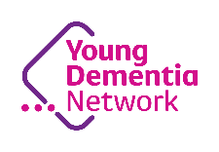
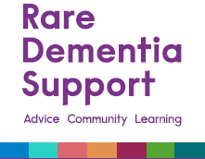
Click logo for more information about all the support St Luke’s offers, or call 01268 524973 or Email: carers@stlukeshospice.co.uk
will be hosting a free webinar on Advance Care Planning and Young Onset Dementia on Tuesday 11th March at 12-1pm. Leading international experts will be offering advice on the importance and challenges of advanced care planning, giving suggestions on how to approach this holistically as well as answering any questions attendees may have. To book a place on the webinar click on the logo or email youngdementianetwork@dementiauk.org
To book a place click on logo or E: youngdementianetwork@dementiauk.org

will be hosting a free webinar on Advance care planning and Young Onset Dementia on Tuesday 11th March at 12-1pm. Leading international experts will be offering advice on the importance and challenges of advanced care planning, giving suggestions on how to approach this holistically as well as answering any questions attendees may have.
To book a place click on logo or E: youngdementianetwork@dementiauk.org

Young Onset Dementia is categorised as someone first developing symptoms before the age of 65 years.
The earliest, noticeable symptom of Young Onset Dementia is often not a deterioration in memory but changes in personality and behaviour, social and communication skills, movement and coordination, or in their vision and spatial awareness. More information and advice on YOD, and other less common types of dementia, can be found by clicking on the Dementia UK and Rare Dementia Support logos on the left. Or call the Dementia UK Helpline on 0800 888 6678




Good Grads Company classes are for people living with dementia and their carer/loved one. Sessions offer a creative experience through a combination of music, dance, movement and
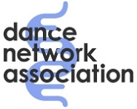

reminiscence. Refreshments are provided and classes are free to attend (though donations are very welcome). Click logo to book a place on any one of the following classes, or call 07490 374 717 or email info@dancenetworkassociation.org.uk
Brentwood Theatre  CM15 8AG | 10:30am-12:30pm  Friday 28th Feb 7th 14th & 21st Mar
Rayleigh Mill Arts & Events Centre  SS6 7ED | 2:30pm-4:30pm  Every Friday from 7th March

To take part in this survey click image or call 0300 500 1895
or email carersvoices@healthwatchessex.org.uk.

