
November 2024
Carers Noticeboard – SWE B&B
A central point of contact for support for unpaid carers 0300 303 9988 Phonelines are open Monday to Friday 8am-7pm Saturday 9am-12pm E: provide.essexwellbeing@nhs.net or https://essexwellbeingservice.co.uk/support/carers/

According to Carers UK, every day around 12,000 people in the UK become unpaid carers for a partner, family member or a friend. Many don’t see them-selves as carers and are often unaware of their legal rights and what they are entitled to in terms of support and benefits.
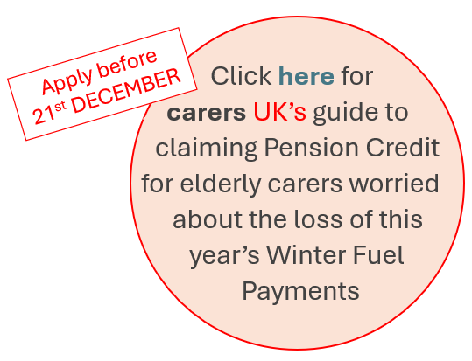
This year’s Carers Rights Day is about helping carers recognise and understand those rights so they can feel confident in asking for what they need plus able to challenge things when their rights are not being met. Whether that’s in the workplace or education, in accessing health or social care, or when interacting with other professionals or at home.
What are your rights as a Carer?
- The right to 5 days unpaid Carer’s Leave per year
- The right to request flexible working
- The right to ask your GP practice to identify you as a Carer
- The right (and choice) to request a free flu jab
- The right to request a Carer’s Assessment
- The right to protection against discrimination or harassment for being a Carer
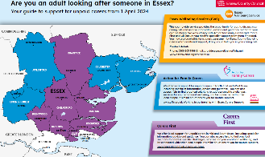
- The right to being consulted when the person you care for is discharged from hospital.
Click on Carers Rights Day logo above for more details or click on the map on the left for Essex County Council’s series of You Tube videos on Carers Rights and Carer’s Assessment.
Email me at gillian.hopkins@nhs.net if your practice would like printed copies of ECC’s Carers Map or the EWS pocket guide to help promote carers support services to patients.


On Carers Rights Day Carers First will be hosting a free webinar for working carers to learn about their rights in the workplace, including their entitlement to Carers Leave and to request flexible working arrangements. This webinar will be held over Zoom from 12:30pm-1:15pm. Click on their logo to register a place.


Carers UK’s latest State of Caring surveys found caring can have a negative impact on some peoples’ ability to work as well as on their mental and physical health (click logo for survey reports). From the carers surveyed:
51% said their financial situation had affected their mental health. Rising to 88% of those carers who said they were struggling to make ends meet
79% said their caring responsibilities made them feel stressed/anxious, 49% felt depressed, 50% felt lonely and 54% said their physical health had suffered
22% said their caring responsibilities meant they had to reduce their working hours 40% had-to give up working entirely
48% said caring had had a negative impact on their ability to work

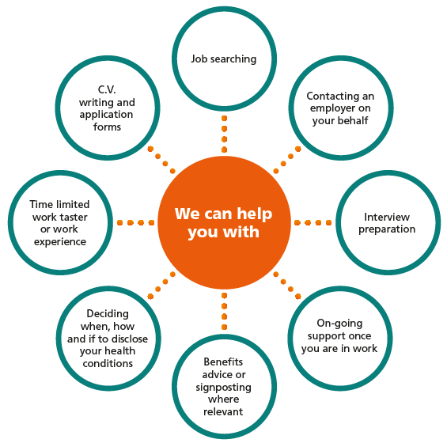

Employment Retention and Individual Placement Support Services can help individuals experiencing mental or physical ill health to retain or gain employment.

When a carers’ mental health is affecting their ability to work, the service can advocate and support them with negotiating reasonable adjustments and with putting a plan together to help them stay or return to work.
The service is available to anyone currently being supported by a community mental health team or specialist mental health service. Click on above logo for more information and for an online referral form.


Provides personalised practical and emotional support to families of children and young people (under 18yrs) receiving treatment for cancer who live in Southend or Basildon. Click logo for further information or E: hello@goldgeese.org


The Alzheimer's Society offers a range of support services for people living with a dementia diagnosis as well as for their family and friends. Their Dementia Advisors are now on hand in Basildon, Southend and Broomfield Hospitals to offer support when people with dementia are admitted onto wards and when being discharged.
The Society’s Side by Side befriending service helps people with dementia to continue with their hobbies and interests and to start doing new activities by matching them with a volunteer with the same interests. Whether that’s going to the football, enjoying a trip to the cinema or jogging around the park. A survey In 2019 found 99% of service users agreed their life was made better in some way as a result of regular contact with their Side by Side volunteer. Although Side by Side is not a respite service, people acknowledged that it could help to give their carer a break. For more information about Side by Side email: sbsessex@alzheimers.org.uk Click logo to find more dementia support services in your area.
Alzheimer’s Society Singing for the Brain group sessions
For people with dementia and their Carers. Singing improves brain activity, wellbeing and mood, and you don’t need to be a good singer to benefit ! Friendly and experienced group leaders host sessions with a wide variety of familiar and new songs. Opportunity to meet new people in a friendly, fun and social environment.
Singing for the Brain, Brentwood - 20th November, 2pm - 3:30pm  3rd Wednesday of every month  Merrymeade House, Merrymeade Chase, CM15 9FE | Singing for the Brain, Billericay - 4th December, 2:30pm - 4pm  1st Wednesday of every month  Hannakins Farm Community Centre, Rosebay Avenue, CM12 0SY
Singing for the Brain, Online group, 2pm - 3pm  Every Tuesday  delivered over Zoom | Singing for the Brain, Online group, 11:30am - 12:30pm  Every Thursday  delivered over Zoom
Rayleigh Winter Cafe - 25th November & 9th December, 10am - 12pm  2nd & 4th Mondays of every month  Rayleigh Parish Centre, Rectory Garth, SS6 8BB | Walk & Talk events  Maldon Promenade 3rd Thursday of every month CM9 5JQ  Hylands Park in Chelmsford 1st Tuesday of every month CM2 8WQ


Every 58 minutes somebody is admitted to an Essex hospital with an acquired brain injury (ABI) due to trauma or a stroke. Headway Essex supports people with ABI to live a fulfilling life and also offers support, information and advice to their families. Don’t Forget About Me is a free programme for families/ carers that runs 1 day per week for 5 consecutive weeks. Sessions are delivered by Headway staff with guest speaker slots from a Clinical Psychologist, Neuro Occupational Therapist, Adult Social Care, Solicitor plus other therapists. Programme topics include:
- aspects of brain anatomy and function, and the effects of the injury for the person with an ABI
- how their ABI can affect relationships, roles and responsibilities for the person themselves and loved ones, family & friends
- Coping with these changes and finding ways of managing, plus how to manage feelings of fatigue, stress, anxiety and anger.

The charity hosts support groups and day activities for people with ABI at their South Benfleet Hub. For more information or to refer click on logo above or call 01206 845 945 or email: abisupport@headwayessex.org.uk

Supports the indirect victims of sexual or violent crime providing free practical and personalised support to:
- Parents, siblings and other family members supporting children who are survivors of sexual abuse.
- Non-abusing partners or children of those arrested for sexual offences against children (including online).
- The loved ones of adults who have survived sexual assault as an adult or who were sexually abused as children.
- Family and friends who are supporting someone who has suffered violence, including domestic violence. Click on logo to find out more about the support Restitute offers.

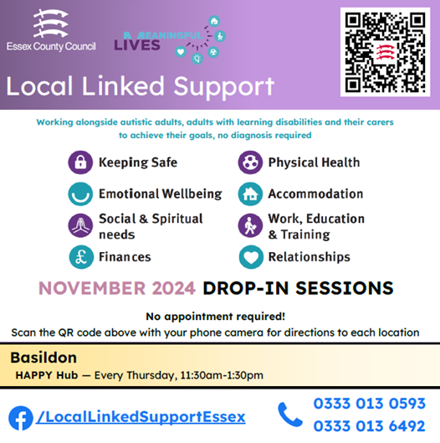

provides information, advice and support for people living with limb loss and their families/ friends. They offer peer mentoring 1:1 support for individuals both pre- and post-amputation who require practical information and emotional support through their limb loss journey. Plus, a national helpline and in-person support groups. To find out more click logo or call 01277 402 331. Email jaynie@limbless-association.org for info on the following support groups:
Corringham LA Community Hub Thursday 21st November 10am – 12:30pm
Corringham Fire Station, 43 Fobbing Road SS17 9BN
Billericay LA Community Hub Tuesday 26th November 10am – 1pm
Mayflower Community Hospital, Blunts Wall Rd, Billericay CM12 9SA


provides free custom-made equipment for people experiencing disability through infirmity, illness or ageing.
Their highly skilled volunteers make equipment / adaptations to support with many things including: mobility and access issues, independent living (e.g. eating & drinking), managing personal care, sports & hobbies. Click logo for REMAP’s Easy Read guide and for more information. Or call 01732 760209 or Email: data@remap.org.uk

